**Name: Mohammad Awais**

**Class: BSCS-8-A**

**CMS: 242554**

Compiler Construction Lab 4

# Task 1

### Update:

**<, >, = are added in operator section as follows**

### test25.l.txt:

%%

(("if"|("then")|("begin")|("end")|("procedure")|("function"))) {printf("A keyword: "); ECHO; printf("\n\n");}

([+-/*=<>]) {printf("An Operator: "); ECHO; printf("\n\n");}

([\n\t" "]) {}

(([0-9]+)(.[0-9]+)?) {printf("A number: "); ECHO; printf("\n\n");}

([a-z]+[0-9a-zA-Z]*) {printf("An id: "); ECHO; printf("\n\n");}

. {printf("Unrecognized character: "); ECHO; printf("\n\n");}

%%

int main(int argc, char **argv)

{

if(argc>1)

yyin=fopen(argv[1],"r");

else

yyin=stdin;

yylex();

}

### Output:

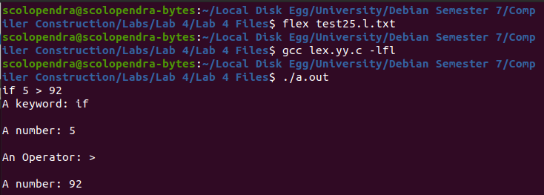

# Task 2

### Improvement:

**The flex specification are too simple, like the arithematic and relational operators are mentioned together in the recent update. Also even all the keywords weren’t used in specifications, symbol table might be a good choice to keep all keywords in and then used the keywords from there to specify keyword label.**